Copyright for test papers and marking guides remains with West Australian Test Papers.
The papers may only be reproduced within the purchasing school according to the advertised Conditions of Sale.
Test papers should be withdrawn after use and stored securely in the school until Friday 6th December 2013.



PHYSICS

YEAR 11

2A/2B

2013

SOLUTIONS

Section 1: Short Answers

Question 1 (3 marks)
Answer true or false to each of the following.

(a) FALSE

(b) TRUE

(c) FALSE

Question 2 (4 marks)

Step 1 cooling from 20 ºC to 0 ºC
Q = m c ΔT = 0.7 x (4.18 x 10³) x 20 = 58 520 J
Step 2 freezing at 0 º
Q = m L = 0.7 x (3.34 x 10⁵) = 233 800 J
Step 3 freezing from 0 ºC to -4 ºC
Q = m c ΔT = 0.7 x (2.10 x 10³) x 4 = 5880 J
Total energy = 2.98 x10⁵ J

Question 3 (2 marks)
A comprehensive description of any of the safety devices such as a fuse, earth leakage systems (RCDs), earth wires would attract maximum marks.

Question 4 (3 marks)
The molecules of liquid petrol are moving about within the liquid with a particular quantity of kinetic and potential energy. At the surface some molecules escape the liquid and gain energy as they enter the space above the liquid. After some time an equilibrium develops between molecules in the liquid phase escaping, and molecules in the vapour phase re-entering. A vapour pressure, due to the energy of the molecules in the vapour phase, exists above the surface.

Question 5 (3 marks)
(a) work = power / time
= 1.5 x (60 x 60) = 5.4 x 10³ J

(b) E = m g h
5.4 x 10³ = 50.0 x 9.80 x h
h = (5.4 x 10³) / (50 x 9.8) = 11.0 m

Question 6 (4 marks)
(a) Calculate the speed of the hammer when it hit the ground.
v² = u² + 2 a s
v² = 0² + 2 x (9.8 x 12)
v² = 235.2
v = 15.34 m s⁻¹

(b)
F t = mv - mu
Ft = m(v – u)
F x 0.300 = 4.0 x (15.34 – 0)
F = [4 (15.34 – 0)] / 0.300
F = 205 N

Question 7 (4 marks)
(a) Work = V q
Work (energy) = (-1.6 x 10⁻¹⁹) x (120 x 10³)
= 1.92 x 10⁻¹⁴ J

(b) 98/100 of (1.9 x 10⁻¹⁴) = 1.882 x 10⁻¹⁴
E = ½ m v²
1.882 x 10⁻¹⁴ = ½ x 9.11 x 10⁻³¹ x v²
v² = (1.882 x 10⁻¹⁴) x 2 / (9.11 x 10⁻³¹)
v² = 4.131 x 10¹⁶
= 1.02 x10⁸ m s⁻¹
V = 10⁸ m s ^{– 1}

Question 8 (3 marks)
The key concept here is diffusion of gases. Prior to the bottle being opened, the liquid is in equilibrium with the vapour. When the bottle is opened, particles of the liquid change phase at the interface between the liquid and the air, escape the surface and move beyond the bottle. The particles have kinetic energy and travel through the surrounding air. Particles travel relatively long distances and can be detected metres away from the source. They travel by colliding with each other and molecules in the air.

Question 9 (4 marks)
(a) I = q / t
1.9 = q / (2.5 x 60 x 60)
quantity of charge (q) = 1.9 x (2.5 x 60 x60)
q = 1.7 x 10⁴ C (2 marks)

(b) Work = V I t
Work = 3.0 x 1.9 x (2.5 x 60 x 60)
Work done in moving the charge = 5.1 x 10⁴ J (2 marks)

Question 10 (3 marks)
The current drawn by the heater when operating at its rated power output.
Power = V I
(2.5 x 10³) = 240 x I
I = (2.5 x 10³) / 240
I = 10 A
This current is above the 8.00A rating of the power board so there is a risk of damage to the power board if a current exceeding the rating is drawn through it.

Question 11 (4 marks)

(a) The arrows should show relative magnitudes. Lift is greater than weight and force is greater than drag (2 marks)
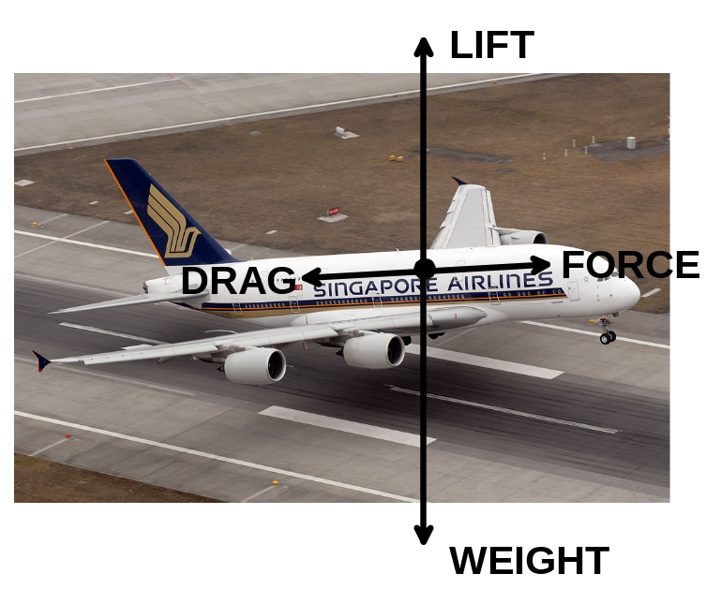

(b)
F = m g
F = (5.60 x 10⁵) x 9.8
F = 5.49 x 10⁶ N (2 marks)

Question 12 (6 marks)
(a)
LHS of equation RHS of equation
[4 x (1.67 x 10⁻²⁷)] + [2 x (9.11 x 10⁻³¹)] (6.64 x 10⁻²⁷)

mass defect = 4.18 x 10⁻²⁹ kg (4 marks)

E = m c²
E = (4.18 x 10⁻²⁹) x (3 x 10⁸)²
E = 3.76 x 10⁻¹² J

(b) 1eV = 1.6 x 10⁻¹⁹ J
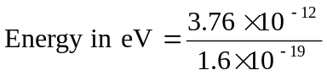
= 2.35 x 10 ⁷ eV
= 23.5 MeV (2 marks)
Question 13 (6 marks)

(a) (i) ¹n₀ + ²³⁵U₉₂ → ¹⁴⁰Xe₅₄ +⁹⁴Sr₃₈ + 2¹n₀

Name of particle - 2 neutrons

(ii) ²³⁹Np₉₃ → ²³⁹Pu₉₄ + ⁰e₋₁

Name of particle - electron

(b)
- ¹³¹I₅₃ → ¹³¹Xe₅₄ + ⁰e₋₁

- ²²⁰Rn₈₆ → ²¹⁶Po₈₄ + ⁴He₂

Question 14 (5 marks)
(a)
Energy before collision = ½ m v² = 0.5 x 0.161 x 25² = 50.3125 J
Energy of ball after collision = 50.3125 – 18.1 = 32.2125 J
E = ½ m v²
32.2125 = 0.5 x 0.161 x v²
v² = 32.2125 / (0.5 x 0.161) = 400.155
v = 20 m s⁻¹ (3 marks)

(b)
Q = m c ΔT
18.1 = 0.004 x (2.25 x 10³) x ΔT
ΔT = 18.1 / (0.004 x 2.25 x 10³)
ΔT = 2.0 ºC (2 marks)

Question 15 (4 marks)
(a) (i) Conduction - Blankets are usually made from non conducting materials (Wool, cotton, synthetics). When the blanket comes in contact with the body there is little heat transferred by conduction from the body to the blanket. Conversely little heat is transferred from the surroundings to the body (1 mark)

(ii) Convection - Blankets are usually woven material with some air trapped between the fibres. As convection depends upon the circulation of gas (air), there is little circulation of air and hence there is negligible loss of body heat through convection. (1 mark)

(iii) Radiation - The material that blankets are made of are typically poor radiators of heat. Lighter coloured fabrics will tend to radiate heat at a slower rate than dark coloured fabrics. However overall the loss of heat through blankets radiating heat is minimal. (1 mark)

(b) The major advantage of doonas over blankets is that they contain large volumes of air which is a very poor conductor of heat. The feathers and fibres can be ‘fluffed up’ to increase the volume of air in the doona envelope hence increasing its insulation properties. Any body heat that is transferred to the doona tends to be trapped in the doona thus reducing heat loss by conduction, convection and radiation. (1 mark)

Question 16 (6 marks)

(a)
v² = u² + 2 a s
0² = u² + 2 x 9.8 x 15.5
u² = 303.8
u = 17.4 m s⁻¹ (2 marks)

(b) 0 ms⁻¹ (1 mark)

(c) Let up be positive
v = u + a t
0 = 17.43 + -9.8 x t
t = 17.43 / 9.8
Time taken to reach maximum height = 1.78 s (2 marks)

(d) The ball will be at the starting point after travelling 31 m. Therefore its speed will be equal to the starting speed = 17.4 m s⁻¹. (1 mark)

END OF SECTION 1

Section 2: Problem Solving

Marks allotted: 100 marks out of a total of 200 (50%)

Question 17 (12 marks)
(a)
Resistance in first parallel circuit
1/R == 1/40 + 1/40
R = 20 Ω
This is in series with another 20 W globe so total resistance is 40.0 Ω
Resistance in second parallel circuit
1/R == 1/40 + 1/20
R = 13.3 Ω
Total resistance in parallel circuits combined
1/R == 1/40 + 1/13.3
R = 10.0 Ω (5 marks)

(b) The meter is in series with the resistors therefore it is an ammeter. So to determine the reading the current needs to be calculated.
V = I R
12 = I x 10.0
I = 12 / 10.0 = 1.20 A (2 marks)

(c) Current in parallel circuit and hence through globe 1
V = I R
12 = I x 40
I = 12/40 = 0.3 A
Current in parallel circuit 2
V = I x R
12 = I x 13.3
I = 12/13.3 = 0.90 A
But the current will be in the ratio of 2:1 through the branches. So the current flowing through globe 2 is 0.3 A. Current flowing through globe 1 is equal to the current flowing through globe 2. (3 marks)

(d) P = I² x R
P = 0.3² x 20 = 1.8 W
The power globe 1 is producing is 1.8 W. Its rating is 2.0 W therefore it is operating below its maximum power output. (2 marks)
Question 18 (12 marks)

(a) Speed = distance / time
17 = 50 / t
Time = 50 / 17 = 2.94 hours (2 marks)
(b) Speed = distance / time
21.0 = 50.0 / t
Time = 50.0 / 21.0 = 2.38 hours (2 marks)

(c) The able-bodied runner took 2.94 hours
The wheelchair athlete took 2.38 hours plus 0.5 hours to complete the race
= 2.88 hours.
The wheel chair athlete won the race because they completed the same distance in less time. (2 marks)

(d) The winner won the race by 3.6 min. (2 marks)

(e) The loser was the runner.
When the winner finished, the runner still had 2.94 – 2.88 hours before finishing
= 0.06 h
Travelling at 17.0 km h⁻¹ he would still have :
17.0 = distance / 0.06
distance = 17.0 x 0.06 = 1.02 km to travel. (2 marks)

(f) The winner took 2.88 hours (including the 30 min delay) to finish the race.
To draw the race the loser would need to maintain an average of speed of:
50 / 2.88 = 17.4 km h⁻¹ (2 marks)

Question 19 (12 marks)
(a) Write an equation for this reaction. (3 marks)
²³⁵U₉₂ + ¹n₀ → ¹⁴⁸La₅₇ ⁸⁵Br₃₅ + 3¹n₀

(b) 3 neutrons are produced per reaction. (1 mark)

(c) Background count is a measurement of the radioactivity that is present in the environment as a result of natural and artificial sources of radioactivity. (2 marks)

(d) Medical radioisotopes, radon from rocks like granite, nuclear fallout from nuclear accidents, detonation of nuclear weapons. (1 mark)

(e) Absorbed dose = E / m = 24 / 85 = 0.282 Gy (2 marks)

(f) Dose equivalent for gamma = 90/100 x 0.282 x 1 = 0.2538 Sv
Dose equivalent for alpha = 10 / 100 x 0.282 x 20 = 0.564 Sv
Total dose equivalent = 0.82 Sv (3 marks)

Question 20 (9 marks)

(a) Calculate the quantity of electrical energy produced by the circuit. (2 marks)
Q = V I t
Q = 12 x 2.5 x (20 x 60)
Q = 36 000 J which is the energy input

- Calculate the quantity of heat energy absorbed by the water. (2marks)
Q = m x c x ΔT
Q = 0.1 x (4.18 x 10³) x (100 – 21)
Q = 3.3 x 10⁴ J which is the energy output

(c) Calculate the efficiency of the system if the aim is to conserve energy between the heating coil and the water. (2 marks)
Efficiency = [(energy output / energy input)] x 100
Efficiency = [33 022) / 36 000] x 100
Efficiency = 92 %

(d) Although heat transfer from the heating coil to the water is efficient, there is some loss of energy by the water to the surroundings. (2 marks)

(e) An insulated vessel that reduces heat transfer from the water to the surroundings would produce a better result. The time taken for the water to reach the final temperature would be reduced so the quantity of electrical energy required to heat the water would be reduced, so
increasing the efficiency. (1 mark)

Question 21 (11 marks)
(a)
Step 1 ²¹⁴Po₈₄ → ²¹⁰Pb₈₂ + ⁴He₂ alpha radiation

Step 2 ²¹⁰Pb₈₂ → ²¹⁰Bi₈₃ + ⁰e₋₁ beta radiation

Step 3 ²¹⁰Bi₈₃ → ²¹⁰Po₈₄ + ⁰e₋₁ beta radiation

Step 4 ²¹⁰Po₈₄ → ²⁰⁶Pb₈₂ + ⁴He₂ alpha radiation (8 marks)

(b)
- The number of decays would decline during this time. (1 mark)

(ii) Pb – 210 and Pb – 206 are isotopes of each other. That is they have the same number of protons in their nuclei but different numbers of neutrons. Pb-210 has 128 neutrons and
Pb-206 has 124 neutrons. (1 mark)

(iii) Pb-206 is a stable isotope of lead. That is, it does not decay spontaneously to produce radiation. The other radioactive elements in the decay chain will continue to decay but when Pb-206 atoms are produced there will be no further decay from that isotope because of its stability. (1 mark)

Question 22 (9 marks)

(a) (2 marks)

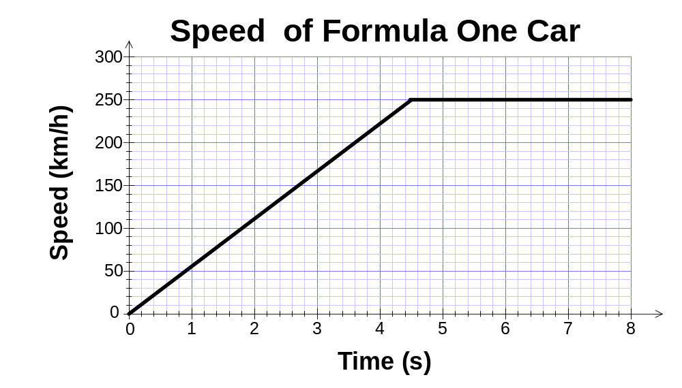

(b) The x axis for the first 4.5 seconds represents an increase in time while the y axis represents the change in velocity. As acceleration is equal to change in velocity divided by time, the GRADIENT represents the acceleration in km h⁻¹ s⁻¹ . (2 marks)

(c) Gradient is (rise / run) = (250 – 0) / (4.5 – 0) = 55.6 km h⁻¹ s⁻¹
This is equivalent to (55.6 x 1000) /3600 = 15.4 m s⁻² (2 marks)

(d) For the first 4.5 s
s = ut + 1/2 a t² = (0 x 4.5) + (0.5 x 15.4) x 4.5² = 156 m
For the next 3.0 seconds
v = s / t = [(250 x 1000) / 3600] = s / 3.0
s = [(250 x 1000) / 3600] x 3
Distance = 208 m
So total distance travelled in 7.5 s = 156 + 208 = 364 m (3 marks)

Question 23 (8 marks)
(a)
Table of results

Measurement | Data
Mass of copper calorimeter | 73.0 g
Mass of calorimeter + warm water | 159 g
Mass of calorimeter + warm water + ice | 193 g
Mass of warm water | 86 g
Mass of ice | 34 g
Initial temperature calorimeter + warm water | 41.6 °C
Final temperature calorimeter + warm water + melted ice | 9.00 °C
Temperature change calorimeter + warm water | 32.6 ºC
Initial temperature of ice | 0.00 °C
Temperature change of melted ice (water) in calorimeter | 9.00 ºC
(2 marks)
Heat gained by ice = Heat lost by calorimeter and warm water
m c ΔT + m L m c ΔT + m c ΔT
(0.034 x 4180 x 9) + (0.034 x L) = (0.86 x 4180 x 32.6) + (0.073 x 380 x 32.6)
1279 + (0.034 x L) = 11 719.048 + 904.324

0.034 L =11 719.048 + 904.324 - 1279
L = (11 719.048 + 904.324 - 1279) / 0.034
L = 3.34 x 10⁵ J kg⁻¹ (6 marks)

Question 24 (7 marks)
(a) Ohms law is V = I R. When an ohmic conductor (resistor) is placed in an electrical circuit and the potential drop across it is measured, the corresponding current through the resistor varies linearly.
A non-ohmic conductor (resistor) does not obey ohms law in as much as the measured potential across the resistor and the corresponding current are not linearly related.
(2 marks)

(b) (i) P = V x I
I = P / V = 5 / 1 = 5.0 A
and
I = P /V = 5 / 100 = 0.05 A
The range of current is from 0.05 A to 5.0 A (2 marks)

(ii) Maximum power rating is 5.0 W. Therefore the maximum energy is 5.0 J in one second (1 mark)

(iii) As the resistor has a constant resistance the factors that determine the power dissipated are the current flowing and the potential applied across the resistor. (2 marks)

END OF SECTION 2

Section 3 Comprehension 16 marks
Question 25

(a) In contrast to petrol driven vehicles, e-bikes produce no undesirable emissions such as methane and carbon dioxide so do not contribute directly to polluting the atmosphere. However because the battery is charged from the mains it could be argued that in the production of the mains electricity, greenhouse gases were produced. (2 marks)

(b) Cycling is a form of exercise that can be undertaken by a wide range of people. Good diet and exercise are recognised as essential things you need to have to promote good health. Cycling increases aerobic performance as well as providing low impact forces on legs and arms. E-bikes allow older people and people with less strength to participate in an activity that they would otherwise be unable to do. (2 marks)

(c)
P = V I
200 = 36 x I
I = 200 / 36
I = 5.56 A (2 marks)

(d) The 10 Ah battery can deliver the equivalent of 10 A for 1 hour
If the battery is delivering 3A then it will deliver power for 10 / 3 = 3.3 hours.
(2 marks)

(e) When engaging the pedal assist function the power output of the motor would decrease. This would conserve the battery’s energy so the distance the rider could travel using the motor would increase. (2 marks)

- Mass of e-bike = 25 kg
Mass of adult rider = 60 kg
Normal force on the path = 85 x 9.8 = 833 N
Estimated horizontal frictional force between wheels and the path = 500 N
(any reasonable estimate which is between 0 and 800 N is acceptable)
Work done by rider = F x distance = 500 x ( 3.5 x10³) = 1.75 x 10⁶ J (2 marks)

(g) I = q / t
2.0 = q / (2 x 60 x 60)
q = 2 x 2 60 x 60
Quantity of charge = 1.4 x 10⁴ C (2 marks)

(h) P = V² / R
200 = 36² / R
R = 36² / 200
R = 1296 / 200 = 6.5 Ω (2 marks)

